

American International University-Bangladesh (AIUB)
Faculty of Science & Technology (FST)

PROJECT TITLE
Weather Forecasting System
Semester: Summer 25-26
Supervised By: JUBAYER AHAMED

Group: |  | Section:
SL | Student Name | Student ID
1 | Sharif Eime Akhter | 24-55989-1
2 | Md sadiqur rahman | 24-56006-1
3 | Fariha Anjum Haque Disha | 23-55201-3
4
5

Assessment Rubric

CO1: Explain the impact of software engineering over various contexts of software development to assess societal, health, safety, legal and cultural issues.

Student ID | Problem Analysis [3] | Socio-cultural Impact [3] | Related Solutions and  Studies [4]
- 24-55989-1
2.24-56006-1
3.23-55201-3
4.
5.

CO2: Explain software engineering principles considering professional responsibilities and societal impacts.

Student ID | Conceptual Understanding [3] | Principle Selection and Justification [3] | Application in Software Development Context [4]
- 24-55989-1
2.24-56006-1
3.23-55201-3
4.
5.

Table of Contents

1. Project Proposal xx
1.1 Background to the Problem xx
1.2 Selection of Process Model xx
2. Timeline Chart / Gantt Chart ………………………….………………………………………………………………...xx
3. Software Requirements Specification (SRS) / PRD xx
3.1 Scopes and Features xx
3.2 User Story Table xx
3.3 Requirements Traceability Matrix xx
3.3.1 Functional Requirements xx
3.3.2 Non-Functional Requirements xx
4. Software Design xx
4.1 System Design xx
4.2 UI Deisgn using Figma xx
5. Git Workflow xx
6. Conclusion xx

- PROJECT PROPOSAL
1.1 Background to the Problem
Nowadays, weather conditions directly affect daily decision-making for individuals, farmers, travelers, and emergency services alike. Most people still rely on inconsistent sources - television broadcasts, word-of-mouth, or outdated static websites—to gather weather information. There are several user roles involved in a complete weather forecasting ecosystem: general users who need quick and accurate forecasts, administrators who manage and validate weather data sources, and the system itself, which must continuously fetch and process real-time meteorological data. When weather information is delivered manually or through fragmented sources, several problems arise: outdated forecasts, lack of location-specific accuracy, delayed severe weather alerts, and no centralized platform for historical weather comparison. Such gaps can lead to poor planning, safety risks during extreme weather events, and overall inconvenience for end users.
This software was created to address all these issues by developing a centralized, real-time Weather Forecasting System that integrates live data fetching, location-based forecasting, and severe weather alerting into a single platform so that every user can access reliable weather information easily. General users can search weather by location, view hourly and 7-day forecasts, save favorite locations, and receive instant alerts for severe conditions. Admins can manage and validate weather data sources, broadcast emergency alerts, and monitor system-wide usage analytics. The system continuously fetches real-time data from external weather APIs, caches it for performance, and logs failures to maintain reliability. With role-based dashboards and continuous data synchronization, the system streamlines the entire forecasting workflow from raw data collection to user-facing visualization making weather information faster, clearer, and more accessible for everyone.
Target Group of Users
The Weather Forecasting System is designed for a wide range of users, including:
- General public who need daily weather updates.
- Students and teachers planning educational or outdoor activities.
- Farmers who depend on weather conditions for agricultural decisions.
- Travelers and tourists planning trips.
- Drivers and transportation service providers.
- Business owners organizing outdoor events or operations.
- Government agencies and emergency respoders monitoring severe weather conditions.

1.2 Selection of Process Model
Selected Model: Scrum
For the Weather Forecasting System, Scrum has been selected as the software development methodology. Scrum is an Agile framework that supports iterative and incremental development. Instead of developing the entire system at once, the project is divided into small development cycles called Sprints. At the end of each Sprint, a working part of the system can be tested, reviewed, and improved. This approach is suitable for our project because it contains several connected features such as weather search, GPS-based location detection, hourly and 7-day forecasts, AQI, radar and satellite maps, personalized locations, weather alerts, and administrative functions.
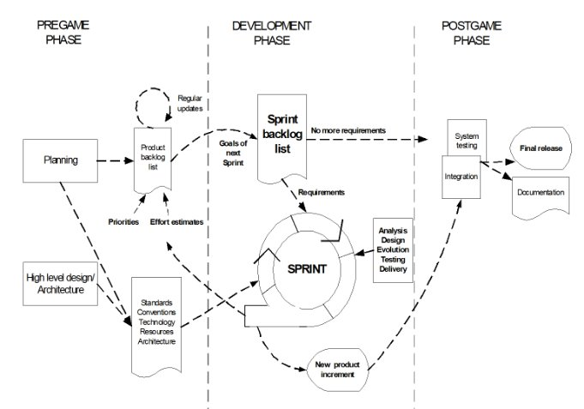
Figure 1: Scrum Development Cycle
Why Scrum Was Selected
Scrum was selected because the requirements of a weather forecasting application may change during development. For example, the project may require a different weather API, additional forecast parameters, improved alert features, or changes to the user interface after testing and feedback. Scrum allows these changes to be added to the Product Backlog and prioritized for a suitable Sprint without redesigning the whole system.
The project can also be divided naturally into smaller modules. Basic weather searching can be developed first, followed by GPS and forecasting, AQI and maps, personalization and alerts, and finally administration and system management. This incremental approach helps the team identify technical problems early and continuously improve the application.
Scrum Process for the Weather Forecasting System
The Scrum process begins with a Product Backlog containing all required features and tasks. During Sprint Planning, the team selects high-priority tasks for the next Sprint. During the Sprint, the selected features are designed, implemented, integrated, and tested. At the end of the Sprint, the completed work is reviewed and feedback is collected. A Retrospective is then used to identify what went well and what should be improved in the next Sprint.
Product Backlog → Sprint Planning → Sprint Backlog → Development → Testing → Sprint Review → Improvement → Next Sprint
Scrum Roles
Scrum defines clear responsibilities among the project participants. The Product Owner represents the requirements and prioritizes the Product Backlog. The Scrum Master supports the Scrum process and helps remove obstacles. The Development Team is responsible for designing, coding, integrating, testing, and delivering the working system increment. In an academic project, these responsibilities can be distributed among the group members according to their assigned tasks.
Advantages of Using Scrum
• Flexible Requirement Management: New weather features, API changes, or user requirements can be added to the backlog and prioritized for future Sprints.
• Incremental Development: The application is developed feature by feature, allowing a working version to be available before the complete project is finished.
• Continuous Testing: Every Sprint includes testing, making it easier to identify and fix defects at an early stage.
• Regular Feedback: Sprint Reviews allow the team and supervisor to evaluate completed features and suggest improvements.
• Risk Reduction: Problems involving API limits, data availability, GPS accuracy, or notifications can be identified and handled early.
• Team Collaboration: Scrum encourages communication, task sharing, progress tracking, and coordination among team members.

Proposed Sprint Plan
Main Activities | Expected Output
Weather search and current weather | Working weather search module
GPS, hourly and 7-day forecast | Location-based forecasting
Weather parameters, AQI and maps | Detailed weather visualization
Favorite locations and alerts | Personalized user features
Admin functions and API management | Administrative module
Integration, testing and improvements | Final working system

Why Scrum Is Suitable for Our Project
Scrum is especially suitable for the Weather Forecasting System because the project depends on external weather APIs and contains many independent features. Each module can be developed and tested separately and then integrated into the complete system. If an API changes its response format or rate limit, the issue can be added to the backlog and handled in an appropriate Sprint. Similarly, feedback from users or the project supervisor can be converted into backlog items and prioritized without interrupting the entire development process Scrum provides a practical and flexible development approach for the Weather Forecasting System. It supports incremental implementation, continuous testing, regular feedback, teamwork, and easier management of changing requirements. By developing the system through planned Sprints, the team can gradually deliver and improve each major feature while reducing development risks. Therefore, Scrum has been selected as the most appropriate methodology for this project.

2.Timeline Chart / Gantt Chart
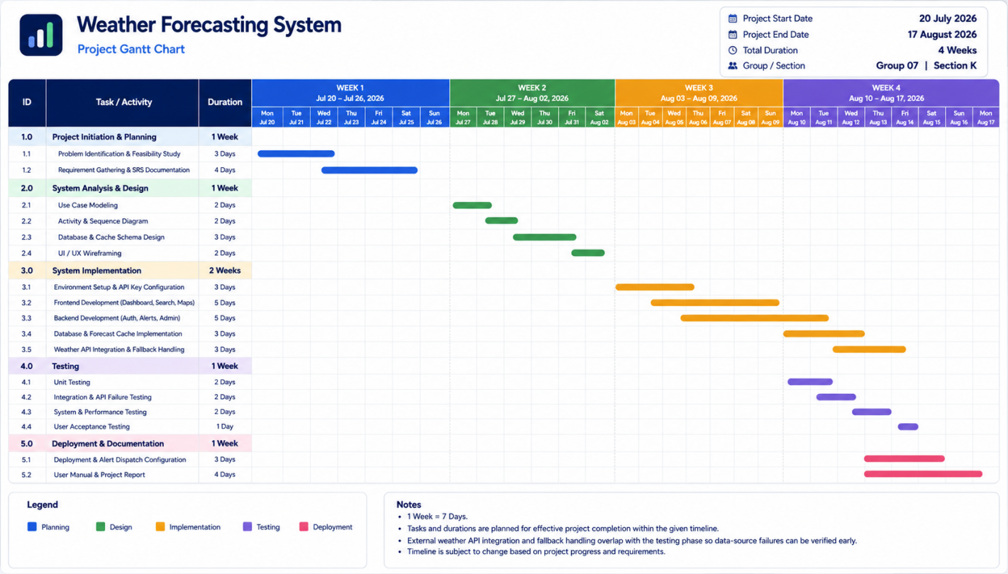

3. SOFTWARE REQUIREMENTS SPECIFICATIONS (SRS)
3.1 Scopes and Features
The scope of the Weather Forecasting System covers user and account management, location personalization, real-time weather forecasting, detailed environmental information, severe-weather alerts, interactive maps, external API integration, data caching, failure handling, analytics, and administrative control.

3.1.1 Scope 1: User Management & Location Personalization
This scope encompasses account creation, role-based authentication for General Users and System Administrators, profile management, password recovery, secure logout, and personalized dashboard capabilities. Users can save favorite geographic locations, select a primary location, customize measurement units such as Celsius/Fahrenheit, choose language preferences, and retrieve localized forecasts after logging in.
- User registration and secure login/logout
- Guest access for basic weather search
- Password recovery and profile management
- Role-based access control
- GPS-based current-location detection
- City/location search

Scope 2: Real-time Forecasting & Emergency Alerts
This scope covers location-based weather querying, current conditions, hourly forecasting, 7-day extended forecasting, detailed weather parameters, AQI information, radar/map visualization, and severe-weather alert processing. Automated push or email notifications will be dispatched when critical weather thresholds are met, while administrators can manually broadcast emergency alerts to selected regions or all users.
- Current weather by GPS or searched location
- Hourly and 7-day forecasts
- Temperature, humidity, wind speed, precipitation and UV information
- Rainfall probability and sunrise/sunset information
- Air Quality Index (AQI) display where data is available
- Interactive radar and satellite/weather map views
- Daily forecast summaries
This scope focuses on automated external API integration, weather-data synchronization, caching for low latency, failure logging, secondary-provider fallback, weather-source validation, historical comparison, API usage monitoring, and system-wide administrative analytics.
- Periodic external weather API data fetching
- Weather payload parsing and normalization
- Forecast caching
- Primary-to-secondary API fallback
- API failure and latency logging
- Historical weather comparison
3.2 User Story Table

General User Stories:
As a/an | ID | I want to | So that | Acceptance Criteria
User | US-01 | Search weather by city or location name | I can check forecasts for any place worldwide | The system accepts a valid city/location query and displays current weather and forecast data.
User | US-02 | Detect my current location automatically via GPS | I do not need to search manually every time | The system obtains coordinates, geocodes them, and displays localized weather.
User | US-03 | View a 7-day extended and hourly forecast | I can plan my daily tasks and week ahead | Hourly and 7-day forecast data are displayed for the selected location.
User | US-04 | See detailed weather parameters and AQI | I can make informed decisions about my day | Temperature, humidity, wind, precipitation, AQI and other available parameters are displayed.
User | US-05 | Save favorite locations and set a primary home location | I can quickly check places I care about | A logged-in user can save, view and remove favorite locations.
User | US-06 | Receive daily summaries and severe-weather alerts | I can prepare and stay safe | Eligible users receive configured notifications for daily summaries and critical alerts.
User | US-07 | Customize units and language preferences | I can view information comfortably | Selected preferences are saved and applied to the user's interface and weather values.
User | US-08 | View interactive radar and satellite maps | I can visually understand moving weather patterns | The system loads the available map layer for the selected location.
User | US-09 | Use guest mode or log in to sync preferences | I can choose instant access or cross-device convenience | Guest users can search weather; authenticated users can synchronize saved data.

Administrator User Stories
As a/an | ID | I want to | So that | Acceptance Criteria
Admin | AD-01 | Manage weather data sources and API integrations | Forecast accuracy stays reliable | Admin can add, edit, validate and disable configured weather sources.
Admin | AD-02 | Broadcast emergency alerts to specific regions or all users | Critical safety updates are delivered quickly | Admin can enter title, region, severity and message and publish the alert.
Admin | AD-03 | View system usage analytics and active user counts | I can monitor performance and engagement | Dashboard displays updated user, traffic and usage statistics.
Admin | AD-04 | Manage and resolve user feedback on incorrect weather data | We can continually improve data quality | Admin can review, filter, update status and resolve submitted feedback.
Admin | AD-05 | Manage registered user accounts and roles | I can maintain platform security | Admin can search accounts and change permitted roles/statuses.
Admin | AD-06 | Configure global notification templates and schedules | Messaging remains consistent and timely | Admin can edit templates and notification schedules and save changes.
Admin | AD-07 | View API usage and rate-limit consumption | Third-party weather data usage remains controlled | System displays API request counts, limits, failures and consumption trends.

Automated System Stories
As a/an | ID | I want to | So that | Acceptance Criteria
System | SM-01 | Fetch real-time data from weather APIs periodically | Forecasts remain up to date | Scheduled jobs request, parse and store current meteorological data.
System | SM-02 | Cache recent forecast data locally/server-side | The application loads quickly and remains usable on weak connections | Recent valid data is cached with a defined expiration policy.
System | SM-03 | Log API failures and latency spikes | Admins can detect data-source issues early | Failures, timeouts and abnormal latency are recorded with timestamps.
System | SM-04 | Fallback to a secondary weather API if the primary fails | Users experience minimal service disruption | A failed primary request triggers a secondary-provider request when configured.
System | SM-05 | Geocode coordinates into readable locations | GPS queries map accurately to weather locations | Latitude/longitude is converted to a usable location representation.
System | SM-06 | Purge expired cache and old logs | Storage usage remains optimized | Expired records are removed according to the retention policy.
System | SM-07 | Encrypt sensitive location and credential data | User privacy and security are maintained | Sensitive information is protected in transit and at rest.

3.3 Requirements Traceability Matrix
3.3.1 Functional Requirements
In this section, we will discuss the requirements of the software in detail. Basically, we will categorize requirements based on the users. Based on this, the system's features will be implemented.

3.1.1 Administrator Requirements

 | Requirement Details
1.0 | User home page - All features availability
1.1 | Registration
1.1.1 | Taking name
1.1.2 | Taking email address
1.1.3 | Taking user name
1.1.4 | Taking password
1.1.5 | Taking confirm password
1.1.6 | Taking phone number
1.1.7 | Submitting the form
1.1.8 | Resetting the form
1.2 | Login
1.2.1 | Taking user name
1.2.2 | Taking password
1.2.3 | Providing forgot password option
1.2.3.1 | Submitting e-mail address and getting user info through our e-mail id
1.2.4 | Submission of the login
1.3 | Dashboard
1.3.1 | Side menu
1.3.1.1 | Dashboard button [ref 1.3]
1.3.1.2 | View profile button
1.3.1.2.1 | Show name
1.3.1.2.2 | Show e-mail
1.3.1.2.3 | Show phone number
1.3.1.2.4 | Show profile picture
1.3.1.2.5 | Edit profile button
1.3.1.2.5.1 | Show existing name and taking name
1.3.1.2.5.2 | Show existing e-mail and taking e-mail
1.3.1.2.5.3 | Show existing phone number and taking phone number
1.3.1.2.5.4 | Submission of the updated info
1.3.1.2.5.5 | View profile [ref 1.3.1.2]
1.3.1.2.6 | Change profile picture button
1.3.1.2.6.1 | Taking profile picture
1.3.1.2.6.2 | Submission of the updated profile picture
1.3.1.2.6.3 | View profile [ref 1.3.1.2]
1.3.1.3 | Change password button
1.3.1.3.1 | Taking current password
1.3.1.3.2 | Taking new password
1.3.1.3.3 | Taking retype new password
1.3.1.3.4 | Submitting the form
1.3.1.4 | Manage Weather Data Sources
1.3.1.4.1 | Add new weather API source button
1.3.1.4.1.1 | Taking API provider name
1.3.1.4.1.2 | Taking API key
1.3.1.4.1.3 | Taking base URL endpoint
1.3.1.4.1.4 | Submitting the form
1.3.1.4.2 | Show all weather data sources table
1.3.1.4.2.1 | Show API provider name
1.3.1.4.2.2 | Show connection status
1.3.1.4.2.3 | Edit source button
1.3.1.4.2.4 | Delete source button
1.3.1.5 | Broadcast Emergency Alert
1.3.1.5.1 | Taking alert title
1.3.1.5.2 | Taking target location / region
1.3.1.5.3 | Taking severity level (Info / Warning / Critical)
1.3.1.5.4 | Taking alert description
1.3.1.5.5 | Submitting emergency alert
1.3.1.6 | System Logs & Analytics
1.3.1.6.1 | View API failure and cache error log table
1.3.1.6.2 | View user traffic analytics
1.3.1.7 | Handle Users
1.3.1.7.1 | Available user info table
1.3.1.7.2 | Delete user button
1.3.1.8 | Logout button
1.3.1.8.1 | Show login page
1.3.2 | Header
1.3.2.1 | System logo on top left
1.3.2.2 | Logged in as (user name) on top right
1.3.2.3 | Logout button on top right [ref 1.3.1.8]
1.3.3 | Footer
1.3.3.1 | Privacy policy button
1.3.3.2 | Disclaimer button
1.3.3.3 | About us button
3.1.2 General User Requirements
 | Requirement Details
1.0 | User home page - All features availability
1.1 | Registration
1.1.1 | Taking name
1.1.2 | Taking email address
1.1.3 | Taking user name
1.1.4 | Taking password
1.1.5 | Taking confirm password
1.1.6 | Taking phone number
1.1.7 | Submitting the form
1.1.8 | Resetting the form
1.2 | Login [ref Administrator 1.2]
1.3 | Dashboard
1.3.1 | Side menu
1.3.1.1 | Dashboard button [ref 1.3]
1.3.1.2 | View profile button [ref Administrator 1.3.1.2]
1.3.1.3 | Edit profile button [ref Administrator 1.3.1.2.5]
1.3.1.4 | Change profile picture button [ref Administrator 1.3.1.2.6]
1.3.1.5 | Change password button [ref Administrator 1.3.1.3]
1.3.1.6 | Search Weather Location
1.3.1.6.1 | Taking city name / zip code / coordinates
1.3.1.6.2 | Submitting the form
1.3.1.6.3 | Display current weather data (temperature, humidity, wind speed, UV index)
1.3.1.6.4 | Display hourly forecast list
1.3.1.6.5 | Display 7-day forecast table
1.3.1.6.6 | Add to favorite locations button
1.3.1.6.6.1 | Show location added notification
1.3.1.7 | Saved Favorite Locations
1.3.1.7.1 | Show saved locations table
1.3.1.7.2 | View forecast button
1.3.1.7.3 | Delete location button
1.3.1.7.3.1 | Show updated locations table [ref 1.3.1.7.1]
1.3.1.8 | Severe Weather Alert Center
1.3.1.8.1 | Show active severe weather warnings list
1.3.1.8.2 | View alert detail message
1.3.1.9 | Historical Weather Comparison
1.3.1.9.1 | Taking date range and location
1.3.1.9.2 | Submitting the form
1.3.1.9.3 | Show historical weather comparison chart/table
1.3.1.10 | Logout button [ref Administrator 1.3.1.8]
1.3.2 | Header [ref Administrator 1.3.2]
1.3.3 | Footer [ref Administrator 1.3.3]
3.1.3 Automated System Requirements
 | Requirement Details
1.0 | Real-time Data Sync Engine
1.1 | Automated External API Data Fetching
1.1.1 | Query external meteorological APIs periodically
1.1.2 | Parse weather payload (temperature, precipitation, wind speed, severe alert flags)
1.1.3 | Store fetched data into local cache and primary database
1.2 | Error Logging & Fallback Handling
1.2.1 | Detect API connection failure or timeout
1.2.2 | Fallback to cached forecast data
1.2.3 | Log failure entry to admin logs table [ref Administrator 1.3.1.6.1]
1.3 | Automated Alert Dispatch
1.3.1 | Detect threshold breaches (e.g., hurricane warnings, heatwaves)
1.3.2 | Dispatch automated push / email notifications to registered users in affected locations

3.3.2 Non-Functional Requirements
Performance | Core screens (dashboard, location search, hourly & 7-day weather forecasts) should load within 3 seconds on typical 3G rural mobile connections.
Usability | The interface must use simple, icon-first navigation with clear visual indicators, and support local language preferences, so that users with limited digital literacy can operate it confidently.
Reliability / Availability | The system should maintain at least 99% uptime, with critical weather forecasts and severe advisories cached locally so field workers, farmers, and general users can access it during connectivity gaps.
Security | Passwords must be stored using secure hashing (e.g., bcrypt/PBKDF2); sensitive administrative actions (e.g., broadcasting emergency alerts) require multi-factor or OTP verification; access to system logs is restricted by role-based permissions.
Scalability | The backend architecture should support a growing number of concurrent users, travelers, farmers, and system administrators without degradation in performance.
Compatibility | The mobile and web applications should run smoothly on low-end mobile devices (Android 6.0 and above) with limited storage and RAM, reflecting real device conditions across urban and rural Bangladesh.
Maintainability | The system should be built with a modular architecture so that new features (e.g., additional meteorological API feeds or specialized agricultural weather modules) can be added with minimal disruption to existing functionality.
Data Integrity | User profiles, saved favorite locations, and emergency alert records should be backed up regularly to prevent data loss and ensure consistency across weather API feeds, caching, and alert dispatch modules.

SOFTWARE DESIGN
USE CASE DIAGRAM 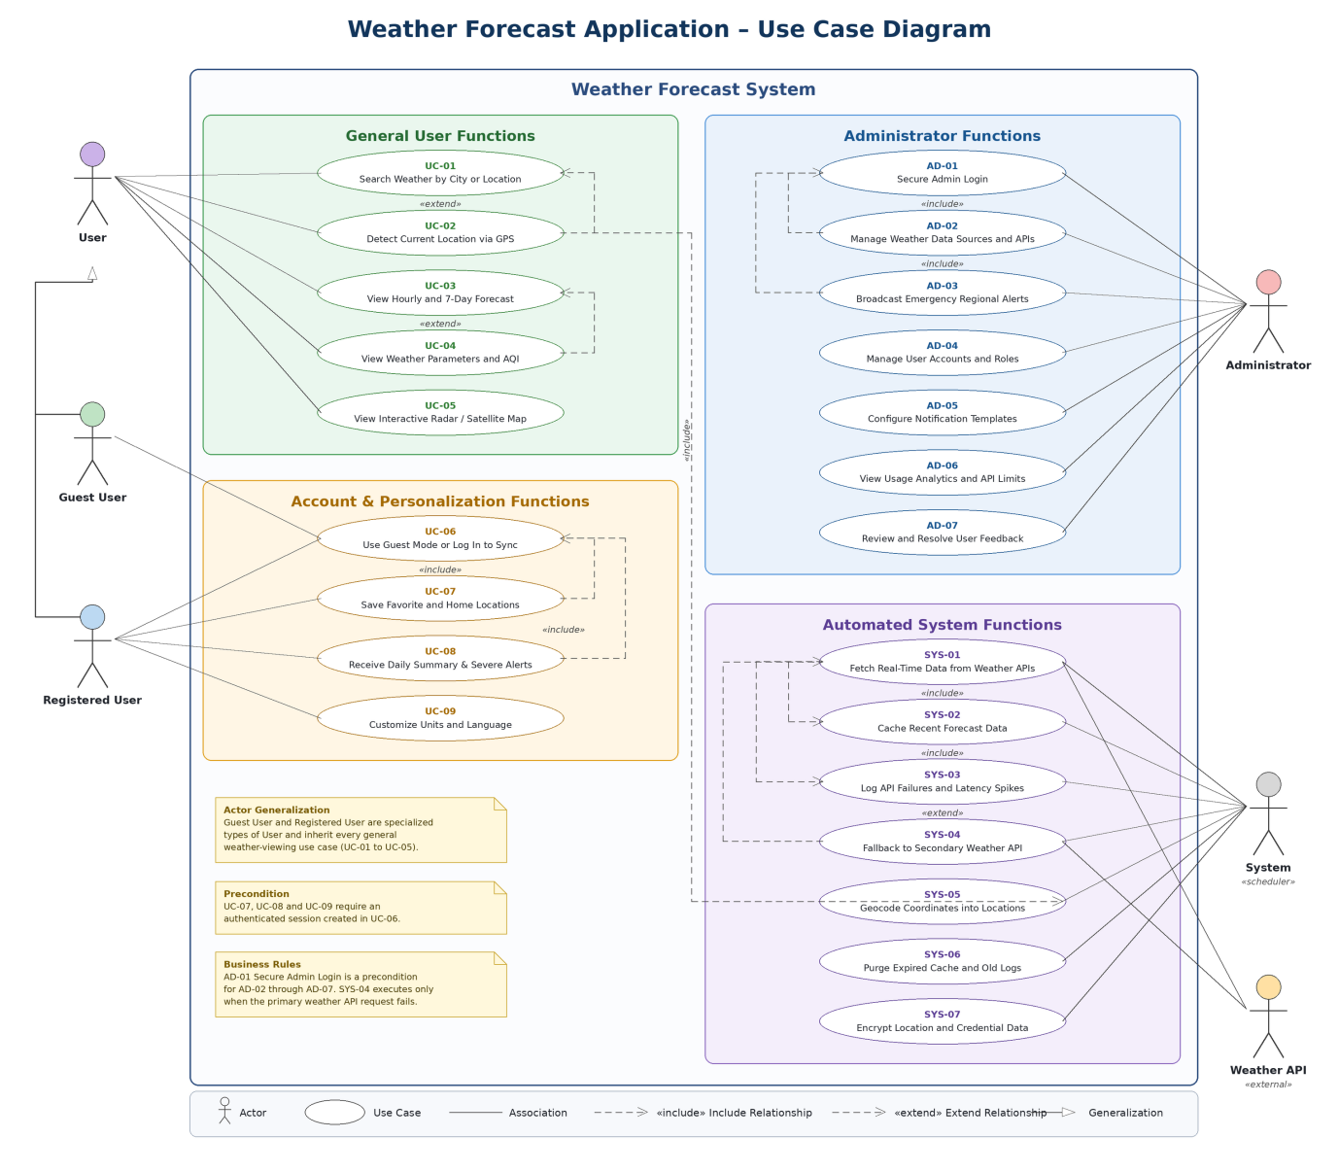
USE CASE DIAGRAM DESCRIPTION

Actors
- User / Guest: Primary end-user who searches weather, views forecasts, manages favorite locations and preferences, and receives alerts.
- Admin: System administrator who manages weather sources, accounts, alerts, analytics, feedback, notification schedules and API usage.
- External Weather API: Third-party provider that supplies real-time meteorological information.

User Functionalities
- View GPS Current Location Weather
- Search Weather by City
- View 7-Day and Hourly Forecast
- View Detailed Parameters and AQI
- Save Favorite Locations
- Receive Push Notifications and Alerts
- Customize Preferences (Units/Language)
- View Interactive Radar Maps
- Login / Account Sync

Admin Functionalities
- Manage Weather Data Sources
- Broadcast Emergency Alerts
- View System Analytics
- Manage User Feedback
- Manage User Accounts and Roles
- Configure Notification Schedules
- Monitor API Usage and Rate Limits

System Operations
- Fetch Real-Time Weather Data
- Cache Forecast Data
- Log API Failures and Performance
- Fallback to Secondary API
- Geocode Coordinates
- Purge Expired Logs and Cache
- Encrypt Sensitive Data

Relationships & Dependency Flow
- Fetch Real-Time Weather Data includes communication with the External Weather API.
- Freshly fetched weather data is cached to improve performance.
- The fetching process includes fallback to a secondary weather provider when the primary source fails.
- GPS-based weather lookup includes coordinate geocoding.
- Failure and latency logging extends the real-time data-fetching process when an error or performance threshold is detected.

UI / Wireframe Design using Figma
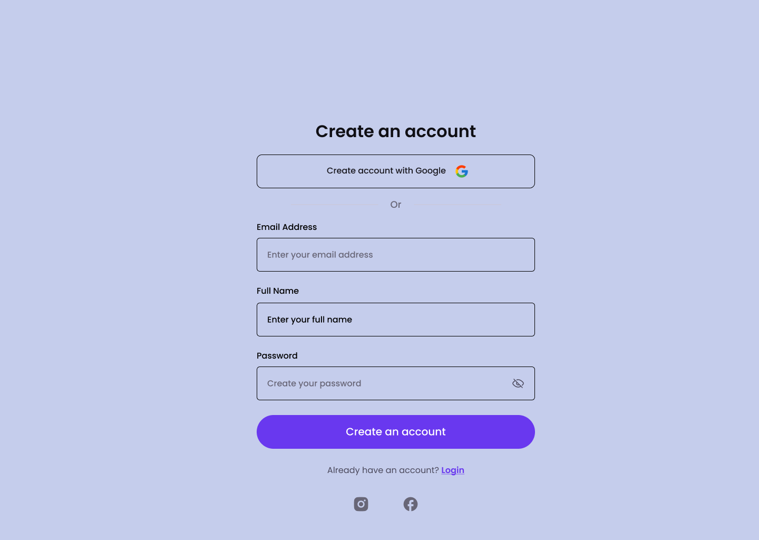
Figure 2: User Registration Interface

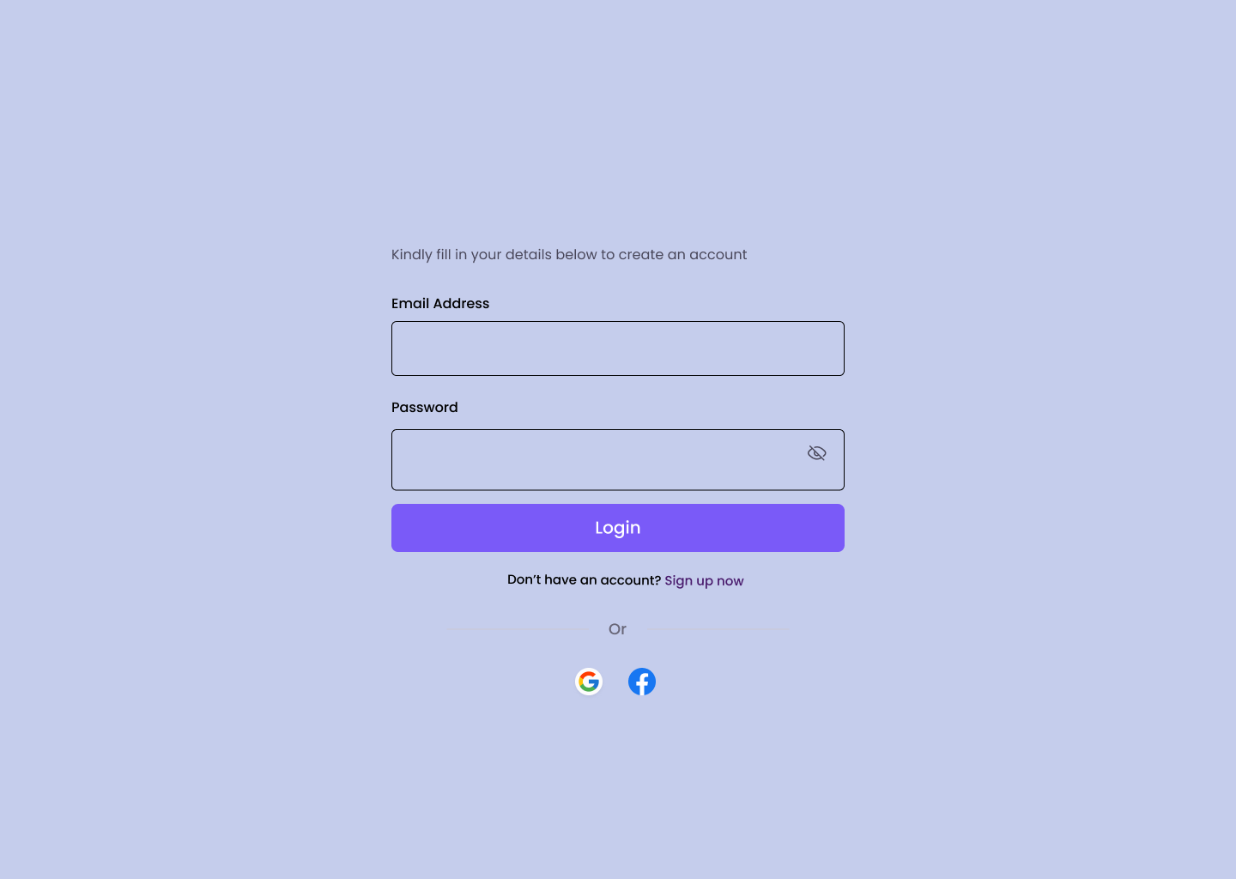 Figure 3: Log in Interface
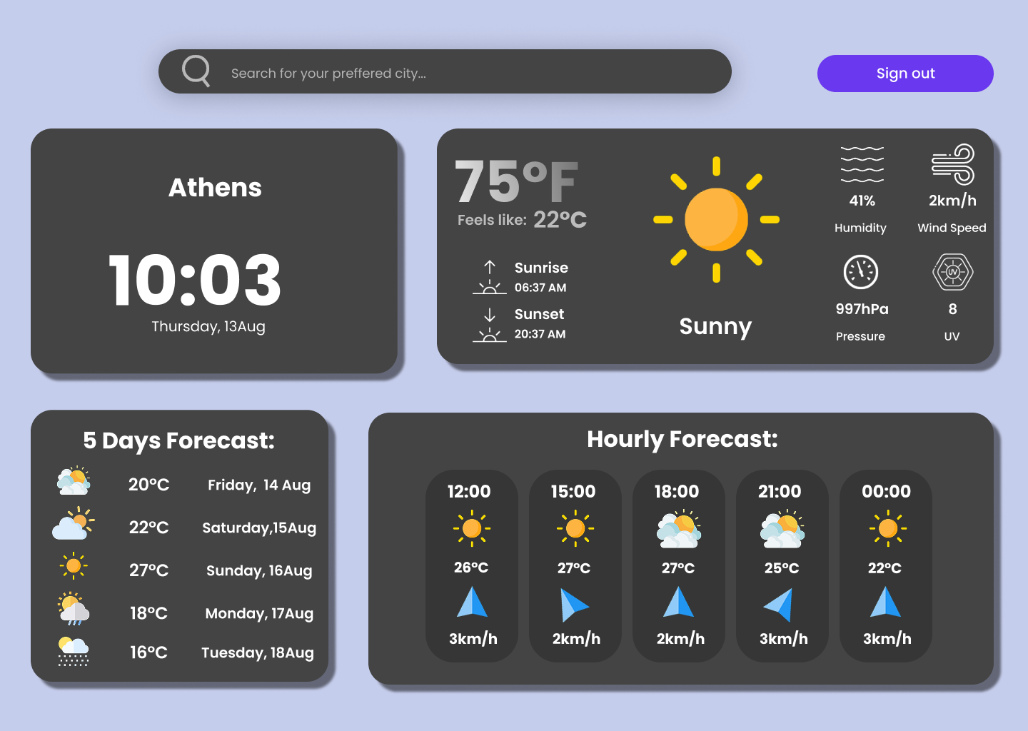Figure 4: Log in Interface
- GIT WORKFLOW
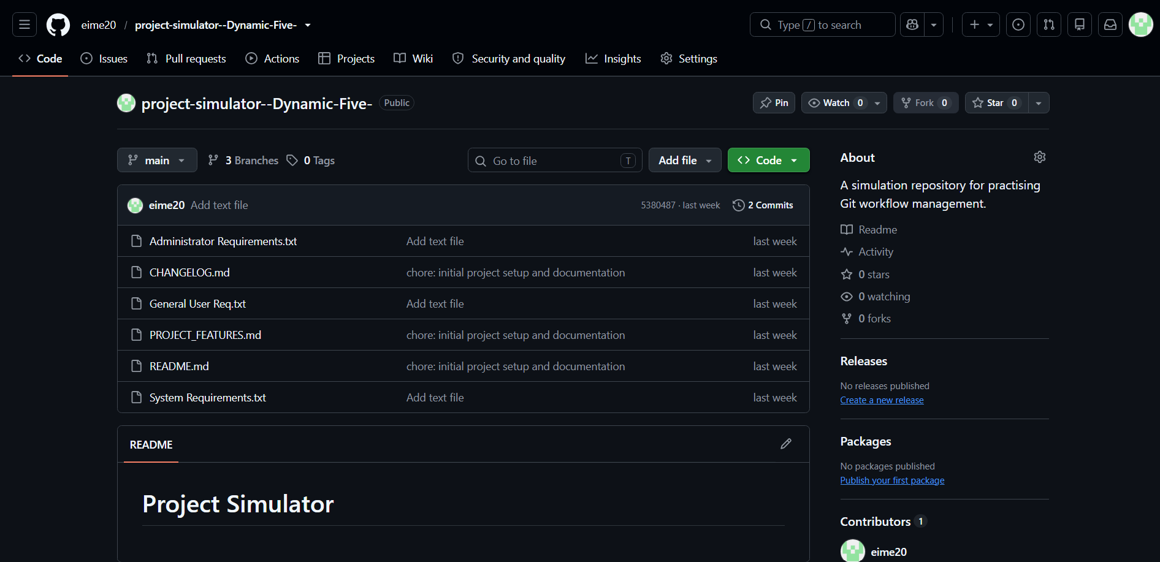
Figure 5.1: GitHub Repository for main branch
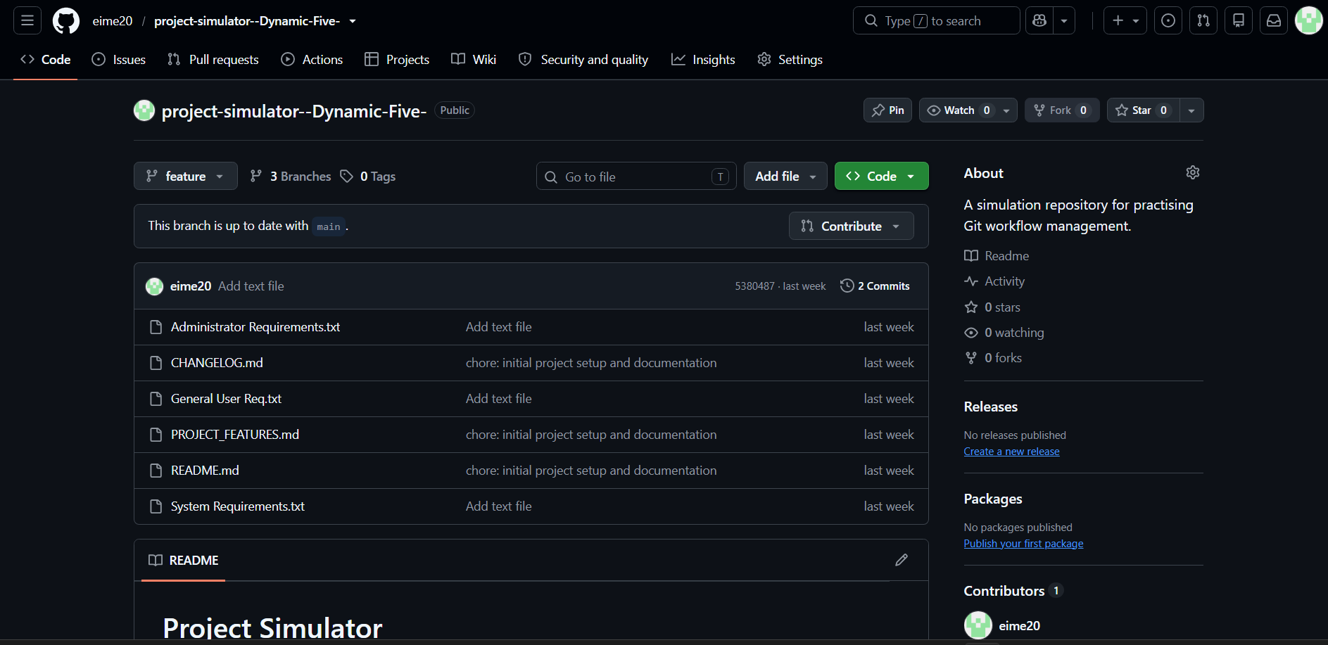
Figure 5.2: GitHub Repository for feature branch
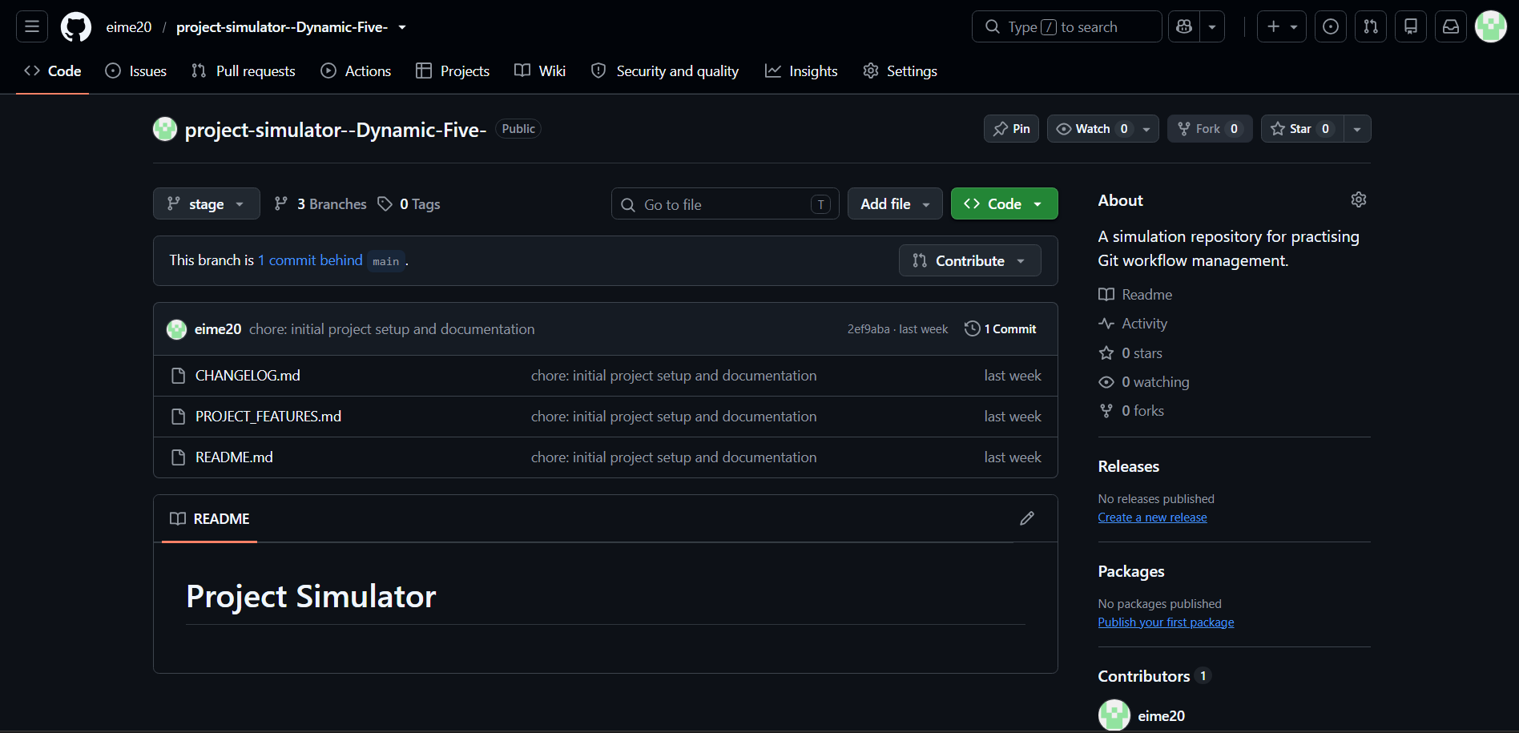
Figure 5.3: GitHub Repository for stage branch
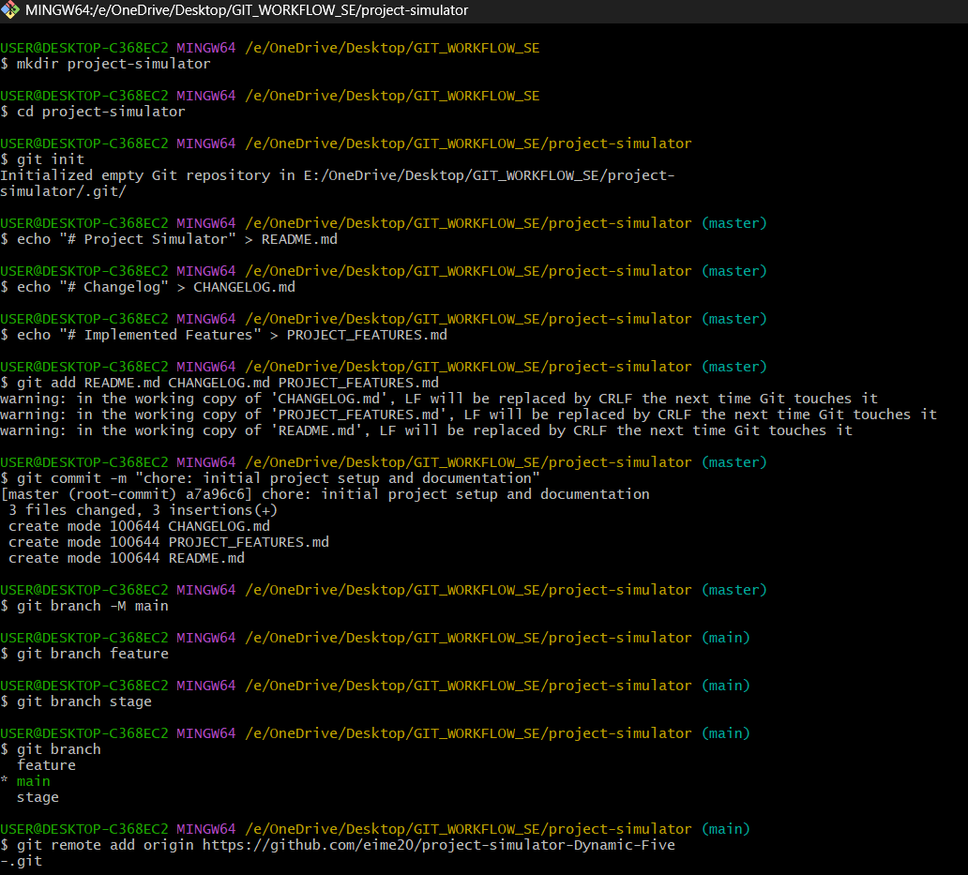
Figure 5.4: Git Commands (24-55989-1)
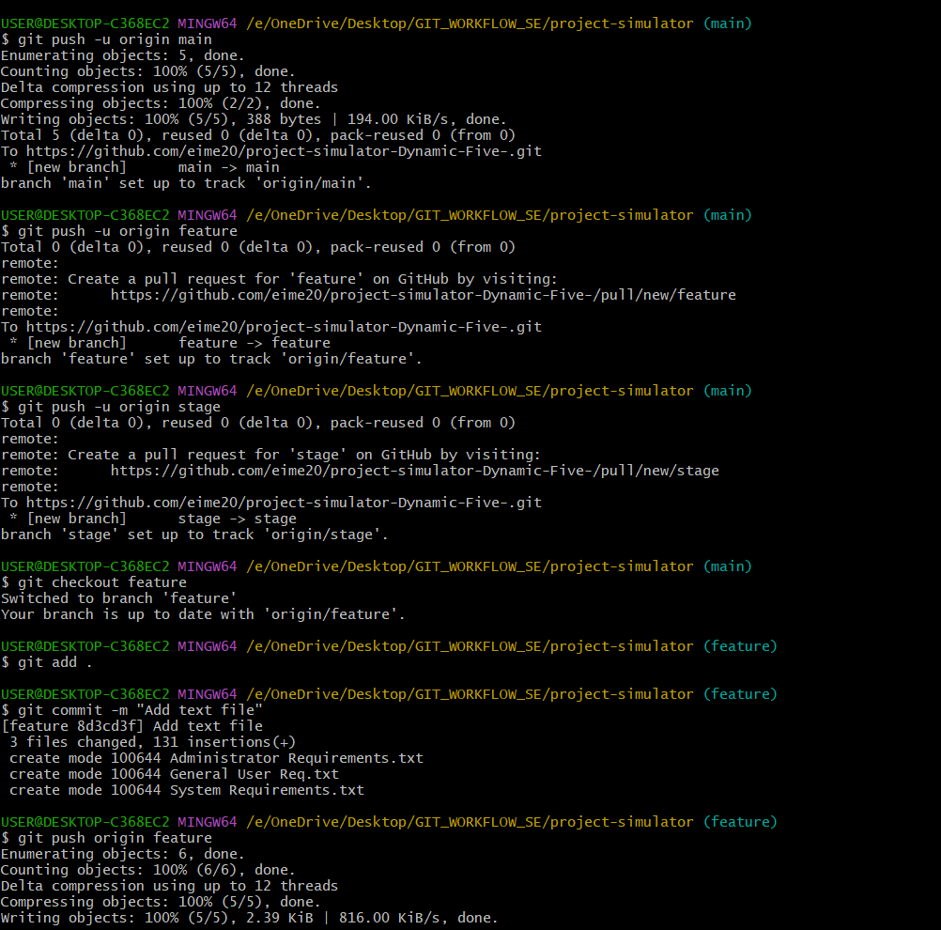
Figure 5.5: Git Commands (24-55989-1)
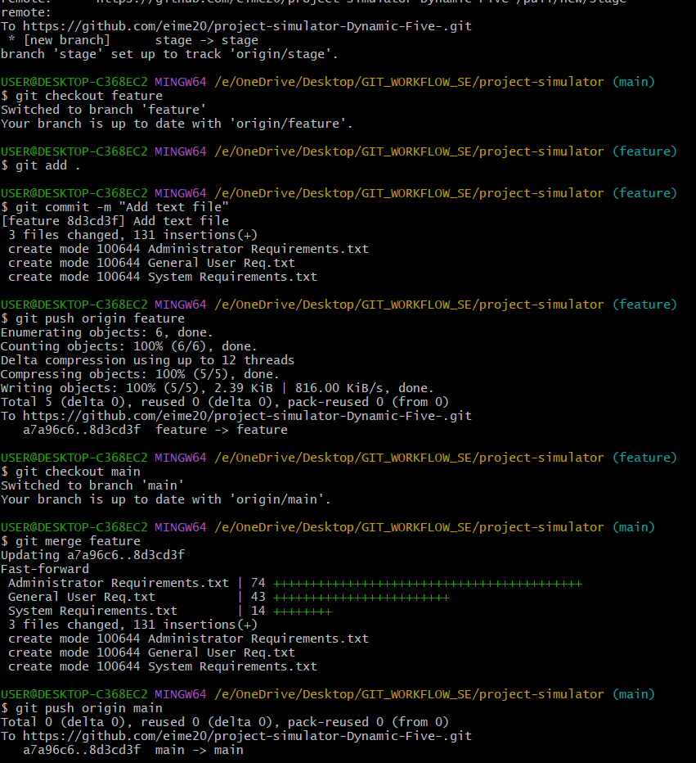
Figure 5.6: Git Commands (24-55989-1)
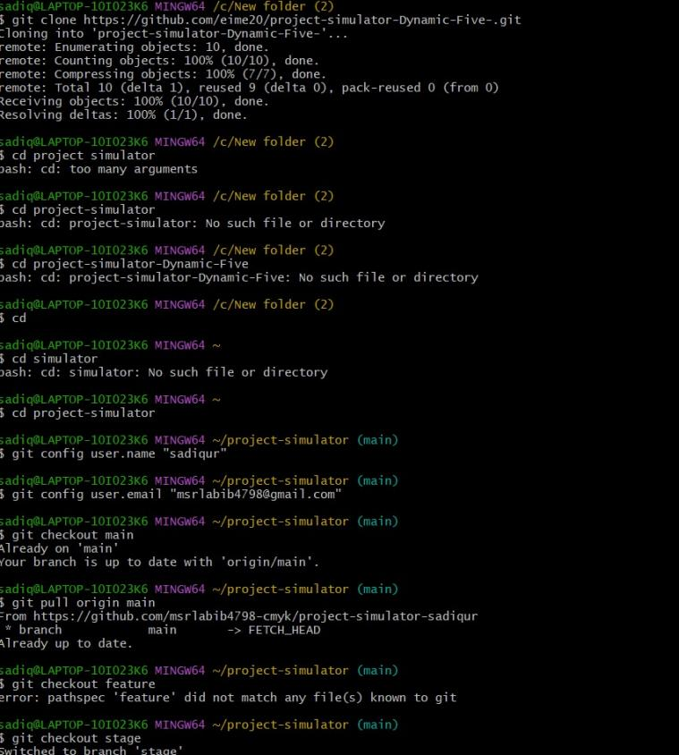
Figure 5.7: Git Clone Commands (24-56006-1)
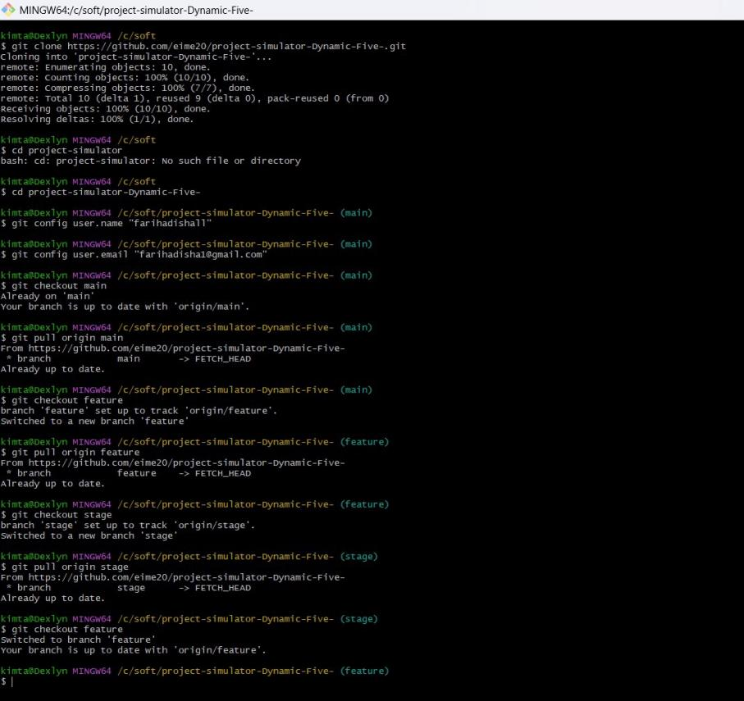
Figure 5.8: Git Clone Commands (23-55201-3)

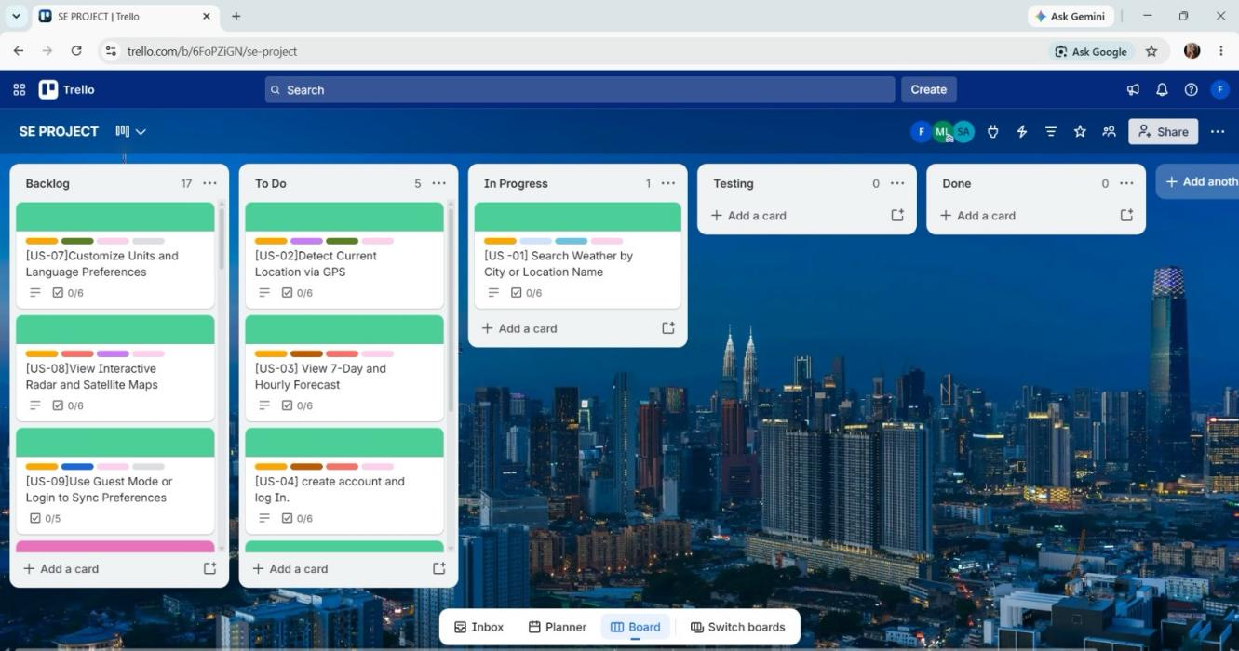
Figure 5.9: Trello Board Screenshot

6. CONCLUSION
The Weather Forecasting System successfully delivers a secure, user-friendly platform that caters to general users, meteorologists, and administrators through real-time weather data integration, location-based forecasting, alerts, historical analysis, and reporting. Developed using Agile Scrum methodology with well-defined user stories, use case diagrams, and interface prototypes, the project establishes a solid foundation through rigorous data security, algorithm testing, and system monitoring, ultimately improving public awareness, disaster preparedness, and decision-making. However, limitations such as dependence on third-party data sources, limited large-scale algorithm validation, restricted scalability, absence of a mobile/offline version, limited hyperlocal accuracy, and minimal multi-language support remain, which future work should address through continuous maintenance and updates to make the system more accurate, scalable, and inclusive.

